Dear Ancients,

Whilst I’m on Long Service Leave, please work on the following tasks. These activities are designed to hone several skills, from your use of appropriate historical vocabulary, to the writing of great historical questions. Today, you will complete Activity 1 (2 questions) and you will begin drafting your research questions; your own Inquiry question (the IQ; the big one!), and 3 or 4 sub-inquiry questions (SIQs).

**Homework: Your draft questions can be emailed to me and Ms W at any time for feedback and ideas,k** but we will officially collect them late next week. SEE YOUR ***FIA2 CALENDAR.docx*** for all checkpoints.

**Source Response Practice (22-04-2025)**

1. Fill the 12 gaps in this response with logical words or phrases.
2. This response is 355 words: See if you can refine it down (removing approx. 50 words) without impacting the student’s ideas or the logical flow of his argument.

Activity *1* **-** Studying an old student response *(20 mins max.)*

**Source 1: The Saqqara Step Pyramid** - Image only

**Reference:** Anon., 2019. *Ministry of Tourism and Antiquities.* [Online]   
Available at: https://egymonuments.gov.eg/en/monuments/step-pyramid-of-djoser  
[Accessed Monday May 2022].

The construction of the Saqqara Step Pyramid under great architect Imhotep amidst the 3rd Dynasty’s reign (2686 – 2613) embodies the ancient Egyptians’ beliefs towards the ancient Egyptian gods, along with a devotion to the Pharaoh Djoser himself. The pyramids of Old Kingdom Egypt are a staple in the country’s long and rich cultural history, with their practical and religious use being to protect royals/elites after their deaths. Imhotep’s incredible devotion to the will of the gods allowed him to ascend to the position of High Priest of Ptah under the tenure of King Djoser (Mark, 2016). The construction of the Step Pyramid started in 2650 BCE, and Imhotep’s newly gained position allowed him to oversee the construction of the Saqqara Step Pyramid to ensure his Pharaoh’s soul had a peaceful journey into the afterlife. Additionally, it is worth noting that the physical shape of the pyramid could represent the “dead king’s ladder to the sky” (Grinsell, 1947).

As much as the architectural structure of the Pyramid is significant to study, the stolen contents which were once inside would have been highly useful in a study of these peoples’ beliefs, rituals, and funerary practices. What we do know is that the pharaohs were believed to have been living incarnations of the god Horus, and they were treated as such. Their mummification and internment processes were thorough and of utmost importance and began with the creation of the tomb, or in this case the Step Pyramid itself. Many of the pharaoh's possessions were encased in the tomb after it was erected as they believed they would need them in the afterlife. After death, the body was preserved through the process of mummification, an expensive task quite literally only fit for a king. The process included the removal all internal organs except the heart before the final steps were taken in mummifying the body (Kennedy, n.d.), as discussed in my response to Source 2. This was just one of the examples on how the ancient Egyptians valued their faith in not just the Egyptian gods, but in the sacred persons that were said to personify them.

Activity *2*–Thinking about my own topic *(for just 20 mins. Please ask Ms Williams to time you all.)*

Now, spend just 20 minutes conducting a little more research your own/chosen culture or civilisation.

* You are looking for general readings, at the moment, rather than complex and high-level r4eadings. You are just getting a ‘feel’ for your topic; for your peoples.
* As you do so, add to your REFERENCE LIST so that you need not worry over it later.
* Have you found a source (perhaps a primary source or an ancient voice) from early in the period you have chosen?
* As you look ar5ound, remember that you will not want overly long OR overly short literary sources. Just save anything you like at this point.

Activity *3*– writing my Inquiry and sub-inquiry questions *(to be emailed to me before ANZAC Day, please)*

Now it’s time to start writing your IQ and SIQs. Finish these for homework. I am asking you to send me your questions before the ANZAC holiday, so do think carefully about the whole process. Historyskills.com is very helpful in this regard. Go to [KEY QUESTION](https://www.historyskills.com/researching/1-key-question/) to begin with and read that webpage really, reeeeally carefully.



It’s not easy to write research questions quickly, particularly if you want them to be ‘naunced’, which of course you do, so here are some written by past Year 11 and 12 students to ponder over. Have a look at each of them, and the comments I have made regarding each. There’s usually a bit of to-ing and fro-ing of student-teacher emails during this Q-writing process.

**A student’s draft questions with teacher feedback:**

**Key Inquiry Question**

**To what extent did the ancient Egyptians value their leaders/pharaohs through their beliefs and the performance of rituals and funerary practices?**

It’s a good start, but it’s a little awkward. Does it have enough in it? It does have 3 parts, which should help with your SIQs: valuing the pharaoh, actual beliefs, and funerary rituals and practices. Now, do your questions reflect these 3? I can see where you are headed with your HYPOTHESIS about valuing the Pharaohs.

Sub Inquiry Questions

1. How did the social status of a person in Old Kingdom Egypt affect ~~their~~ the _________ of their funerary practices?
2. Were funerary rituals in Old Kingdom ~~ancient~~ Egypt primarily physical or spiritual? <Not specific enough, though I can see where you are going with it, sort of. Think like this: While a dead Pharaoh’s physical needs were considered in the treatment and internment of his body, to what degree was ___________________(<Do you see where I am headed? Hint. Hint.)
3. ~~Was~~ there any changes or continuities in respect to the funerary practices involving the rich or the poor in the Old Kingdom? Watch your grammar.

Ah-ha. You haven’t got a question about how valued the pharaoh’s position (as divine himself) such that it took precedence over the lives and deaths, really, of everyday Egyptians….

**Another student’s draft questions with teacher feedback:**

**Key Inquiry Question:** ***In what ways*** did the ~~Vikings’~~ funerary beliefs, rituals and practices of the Vikings *beyond their homelands* change due to the influence of other European cultures between 800 and 1000 CE.? You’ll need to be specific about where – hence *this added phrase might work*.

**Sub-Inquiry Question #1:** Did multi-religious Viking societies all undergo religious change and development? This is a Yes/No or Closed question, and we have to avoid those, Sally. Consider what you actually want from the Q. I suspect you’d be better off with

**Sub-Inquiry Question #2:** Describe the interactions between early-Viking societies on the British Isles and Anglo-Saxon kingdoms in the late 800s and what religious agreements were made to allow for cultural assimilation.

**Sub-Inquiry Question #3**: How did the Mediterranean trade (that was beneficial to the Viking economy) affect…. Incomplete. It’s not easy, is it? Think: funerary practices.

**Sub-Inquiry Question #4:** How did other ~~middle-age~~ societies perceive and interact with Viking culture and its practice? You could use the words ‘contemporary societies’ or ‘contemporary cultures’… and, also, tweak your SIQ to take in some dates, so that it’s nuanced and can envelope any significant changes or continuities in the regard for (or disregard of! lol) the Vikings.

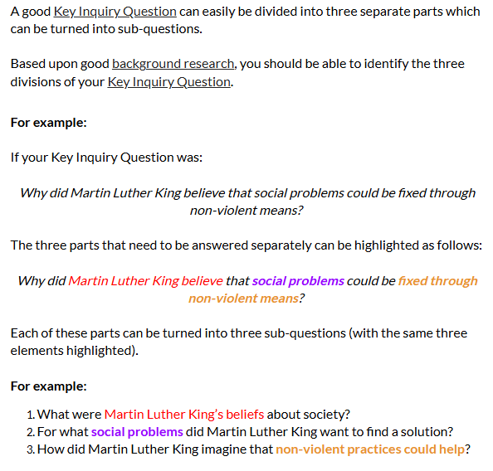Activity *3*, *continued.*

Now, Ancients, have a go at writing your own questions. Don’t worry about how yicky that might sound at first. It takes a while to get them just right. Most of all, remember this great advice, from historyskills.com ([How to develop research sub-questions](https://www.historyskills.com/researching/3-sub-questions/)) à

You will surely change them as your research progresses. It is the most important and rigorously challenging and ***satisfying*** thing, to rewrite and tweak and finally settle on mature and nuanced questions.

Don’t stress. Keep every question you write, no matter how yicky you might think them at the start, and just enjoy the process.